Name of the child | Ivania Centeno Rodríguez
Town or Department | Community: Auhya Pura,  Town: Prinzapolka  North Atlantic Autonomous Region (RAAN).
Age | 10 years old
Sex | Female
Current family context, where they live, their daily lives, the school where they go, difficulties faced as a family. | When we go inside the provisional school of the indigenous community Auhya Pura, along the Prinzapolka river, we found 20 children laughing and talking animatedly. Among them is Ivania, a cheerful girl with long hair who wears a uniform and walk barefoot.  She is 10 and is shy but has not stopped looking and smiling since we arrived. She just talks Miskitu, the language of the indigenous Nicaraguans living mainly in the North Atlantic Region (RAAN).  Ivania tell us that she lives in a little house built on bases of wood, which is near the school and on the riverside.  Her father died four years ago, so now she lives with her mother, stepfather and two siblings, two boys -5 and 12 years old- and two girls –2 and 8-. Her mother, Gertrudis Sanchez, works as a farmer in a small orchard in the path of the river. The rainy season lasts 8 months, and all the houses and crops that are near to the river become vulnerable. The last weeks of July, heavy rains flooded almost all the crops in this community, and Ivania’s family lost all rice and cassava production.  She says that "when the river overflowed, I was sad and bad, mostly because my mom looked scared."  They and most of the community members only get supplies to feed their family because, even though this place is rich in resources, we are in a very inaccessible area. The only way to reach the nearest town is across the river, which has no regular services, but each house has a little canoe. Moreover, the families have not a reserve of production because of the lack of resources to grow more than necessary for subsistence.  While we talk, the rest of children are looking at us, they are cheerful and curious. Still, Ivania shown comfortable, she looks askance at us, smiles and touches her hair. At school are two of her siblings. One of the biggest problems to go to school is the lack of access when it floods the community. Despite the live near “we have to go by canoe and when it rains I am scared because it fills the river”, says Ivania. The school teacher, Tania Moody -20 years old-, tell us that “many children do not usually come due to the weather, because if it rains, those who live far away and have to come sculling cannot come."  Although the family has to face many difficulties, she and her two brothers try to go to the school. However, his 12 years brother cannot attend because at school in Auhya Pura, children can only study up to grade 4.  The school teacher says “Ivania is very studious and hard-working. When I came here, she could neither read nor write; now she writes and reads a little bit". Ivania talks immediately very excited about the new school, which is being built by the Cristian Medical Action with funding from Save the Children “I feel happy because before there was no school and now we have”. For six years, lessons are taught in the church, “the children are very excited about the new school. Always ask me when it will be finished. Here, where we are studying now, we have a lot of problems. Kids have to write crouched on the banks of the church because there are no tables ",explains Tania.  Ivania tell us that her favorite subject is drawing, but “when I leave the school, I like playing with my friends, running, dancing… But also football. Then I have to my homework”. The three siblings wear an uniform, they look happy and play a lot. “When I am an adult, I want to be a doctor or a nurse to come and help my people here”.
Description of the house and the family environment, their attitude, their look, their expression when you talk to them, their interests, ambitions | The 7 members of the family live in a modest house with a single room without bath or shower facilities, only latrines. The mother tells us “rains destroyed everything. We could not recover anything. We lost even the kitchen”. Now, she tries to feed her family fishing, but the river is contaminated. She is waiting in the same church where the kids have lessons until the new school, for the food distribution that Save the Children will give out to 197 families in this community.  "I have always loved that my children come to school, I always come to see them, but it is a problem due to lack of boats." Gertrudis looks tired; however, was all the time showing affection to their kids.
Their views! - Please write down their exact words related to all aspects of their history, what happened, why and when, how they feel today, as it affected the project. | “I am afraid that the river grows again because I see my family very worried and sad for the harvest. I am scared because it wets the entire house and we get sick”, says Ivania. However, when we ask if she would prefer not have the house far away from the river, she affirms “no, I love to live close to the river and play there. I just do not like it when it rains”. Gertrudis assures us that "soon will return to plant corn and cassava, but rice is not possible due to the water. I have fear that the river grows again”.  “Most families here have lost the entire crop. The food which you are going to distribute today is essential because many of them have not how to eat "explains the teacher. During the second week of August, Save the Children has distributed food packages in 10 communities affected by floods in the Prinzapolka river. The grant is part of the rapid response to emergencies project and it consists of 14 pounds of rice, 14 of policereal, 11 of sugar, 4 of salt and 2 liters of oil. Each house affected receives one sack and it caters for a week.  The children of this community are encouraged and optimistic; they all assure us that "the new school is the most beautiful in the river". “It will have three classrooms, latrines and desks. They want to have lessons until 6th grade so we have more chances to end childhood education” tells Ivania smiling.  “Most of the kids do not finish elementary school because there is no possibility to study up more that 4th grade here. Now, we are teaching miskitu, Spanish and math; we have around 70 children”, says the teacher.
Any other quote of the girl or boy. | “I love to play but also help my mom in the home tasks. During the morning, I always pulled water and clean myself with my brothers”.  “I don’t like to see my mum sad due to the crops because we all feel bad”.  “I love playing in the river but I am afraid when it grows because all adults are worried and we cannot get to school”.  “I really want to go to the new school” In one month, we have been told that it will be completed, we will be the first to study there!”
Comments of the family; promoters of the program, community members. | “Ivania always helps me with math" tells Liumat, the younger brother of the girl.  The teacher tells us that "she is very sociable; she has good relationships with all the children. Some kids come without eating and come sad. Then I try to find some food for them and become happier. But still, these children sometimes are lonely. I try to make them socialize more, I propose group works… But Ivania But Ivania always tries to involve everyone in the lesson”.  The mother is proud because their children are studying in elementary school. “I wish they could go to middle school to have more opportunities, but it is difficult because they have to go every day away and is very expensive. Here, many children never go to school because their parents want that they work”. The teacher is also concerned about this issue “most of the children work. At planting time, a lot of them do not come, especially the older ones. Parents do not think that it is important that the kids come to school; they have no interest in them to learn. I always talk with them and insist because it is important that they let them come. "
Background information on the Save the Children project in which they have been involved. | Always in an emergency, children are the most vulnerable sector of the population. Therefore, priority should be given to ensure their basic needs and protect their rights.  The emergency response project in Prinzapolka is based on the distribution of food to replace lost crops after the flooding of the river in 10 communities in which Save the Children already had development projects. Therefore, we feel a responsibility to ensure that basic food needs are satisfied. The beneficiaries of this project are 500 homes with an average of 6 persons each. Moreover, from the third week of August, this emergency response project will also address the cleaning and disinfection of wells in these communities, because due to the flooding of the river, the water has been polluted.  Among the main results of this project, and others mentioned in the text, we highlight:  - In the second week of August (2013), 200 families, approximately 1,200 people, of these 800 children, benefitted from food items for a period of one week.  - Purchase and distribution of Food humanitarian aid items and nutritional supplements (policereal, rice, beans oil, sugar and salt) to support children’s nutrition.  - Coordinate with local authorities to deliver humanitarian Food items.  - This year, the elementary school enrollment of girls and boys has increased 20% compared to 2012, in the 13 communities served by the project in Prinzapolka. This year, a total of 1,341 children were enrolled.  - In 2013 we are building a new school in the community Auhya Pura so that children have access to education. In this community there was not a school previously.
Link with strategic objectives. | It contributes to the fulfillment of the rights of children, food, access and quality of education.
Description of the people in the photo (location, date, work activity). | 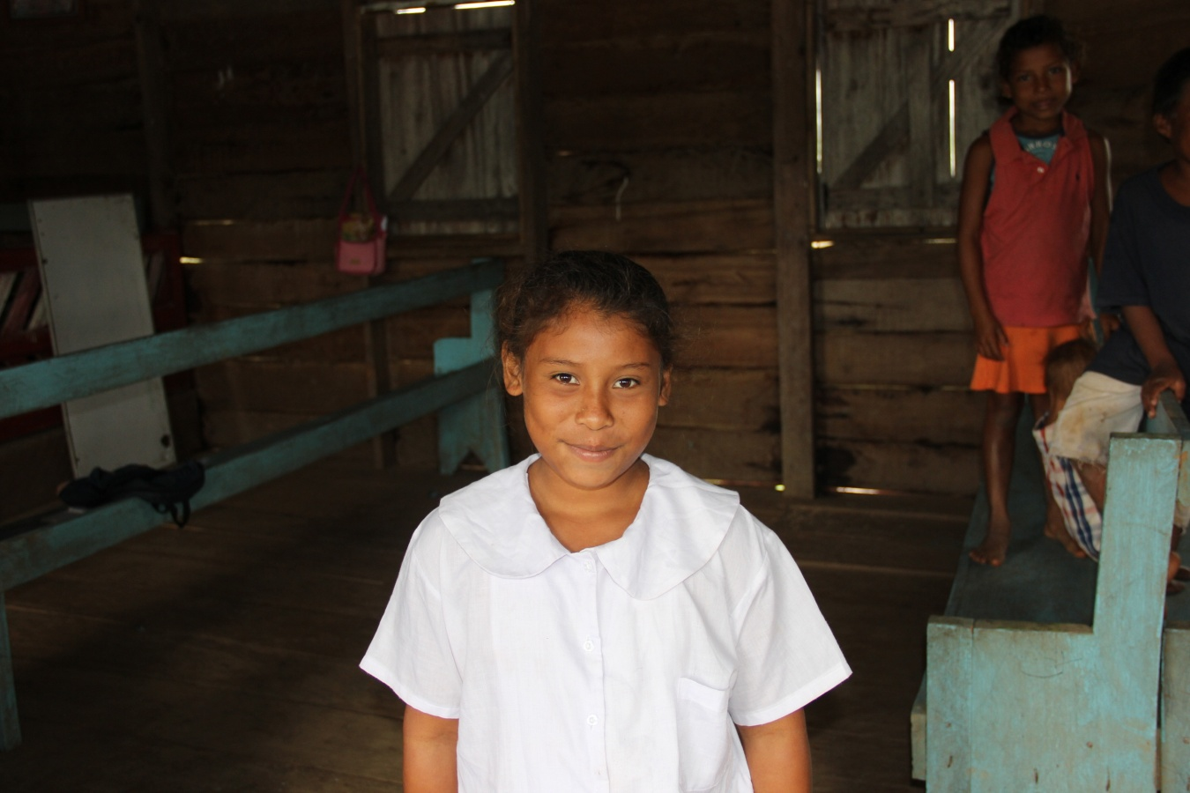  Ivania Centeno Rodríguez, 12.08.13, after the interview in the provisional school of Auhya Pura.  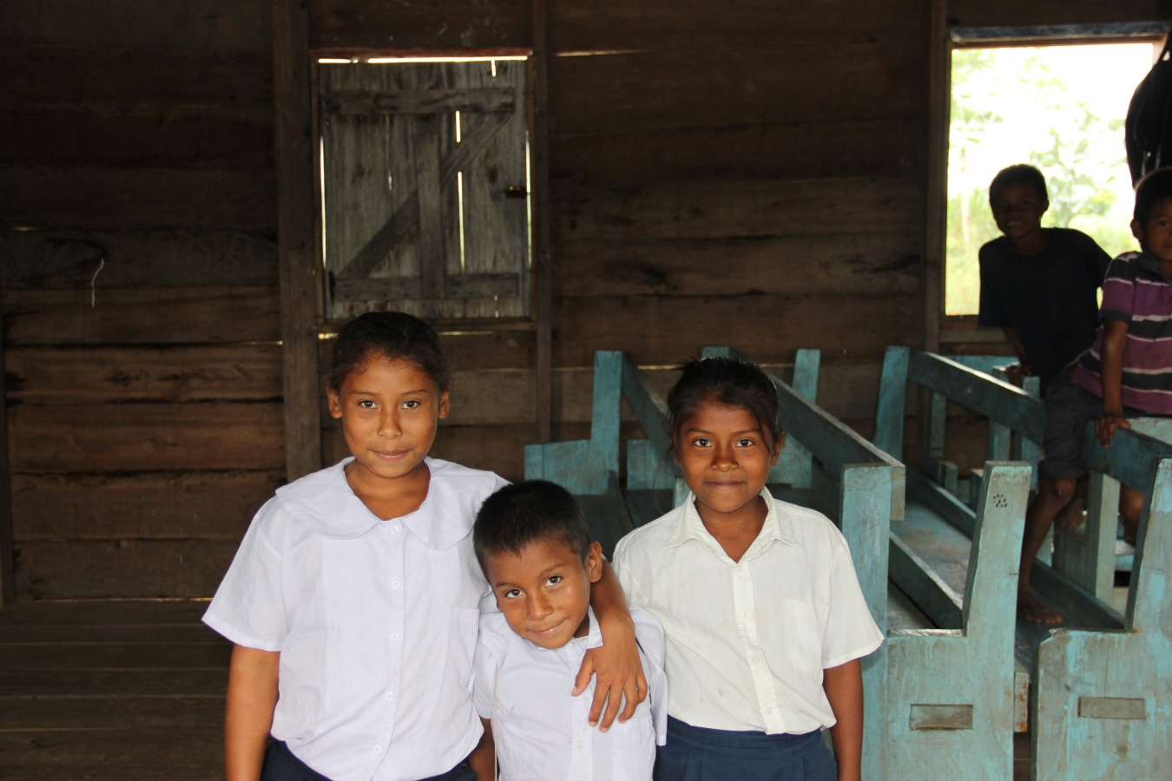  Ivania Centeno and her siblings, Liumat -5- and Anielke -8 years-. 12.08.13  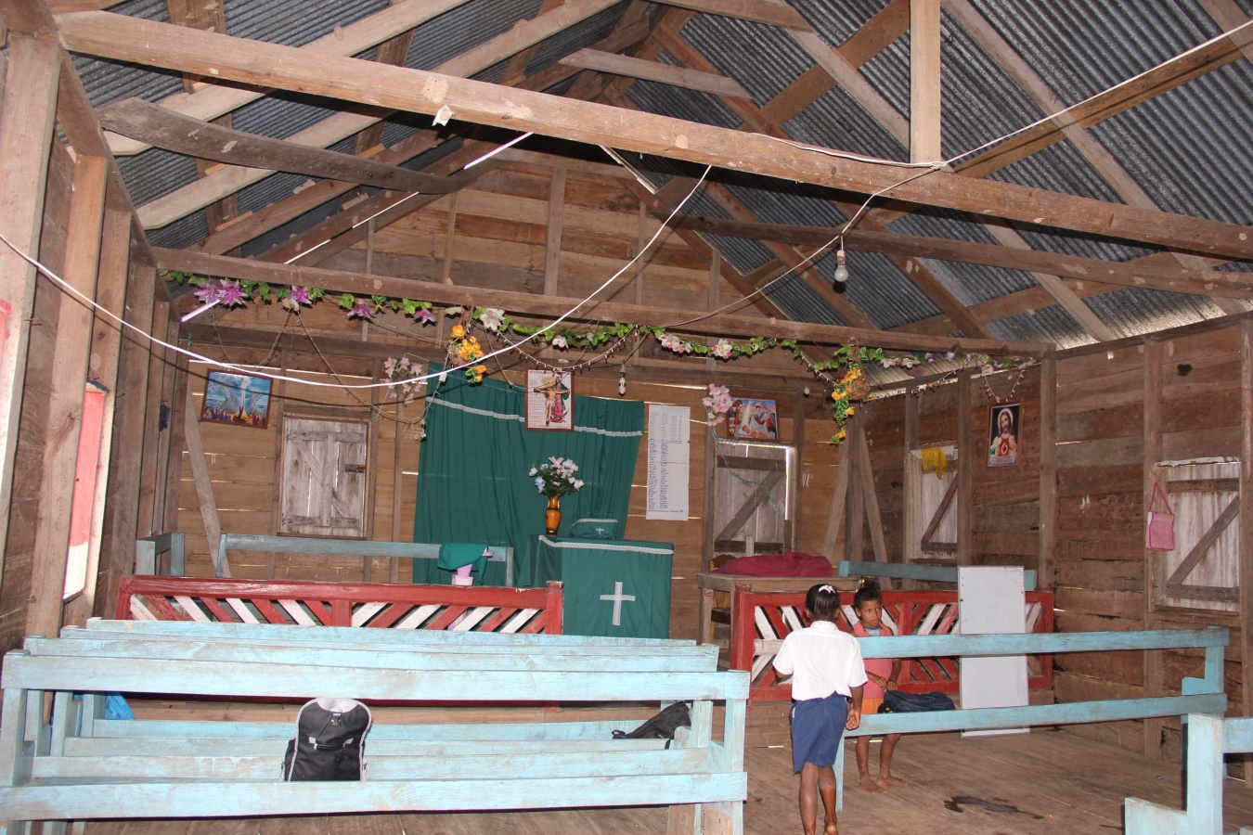  Church where they are teaching lessons for six years. 12.08.13  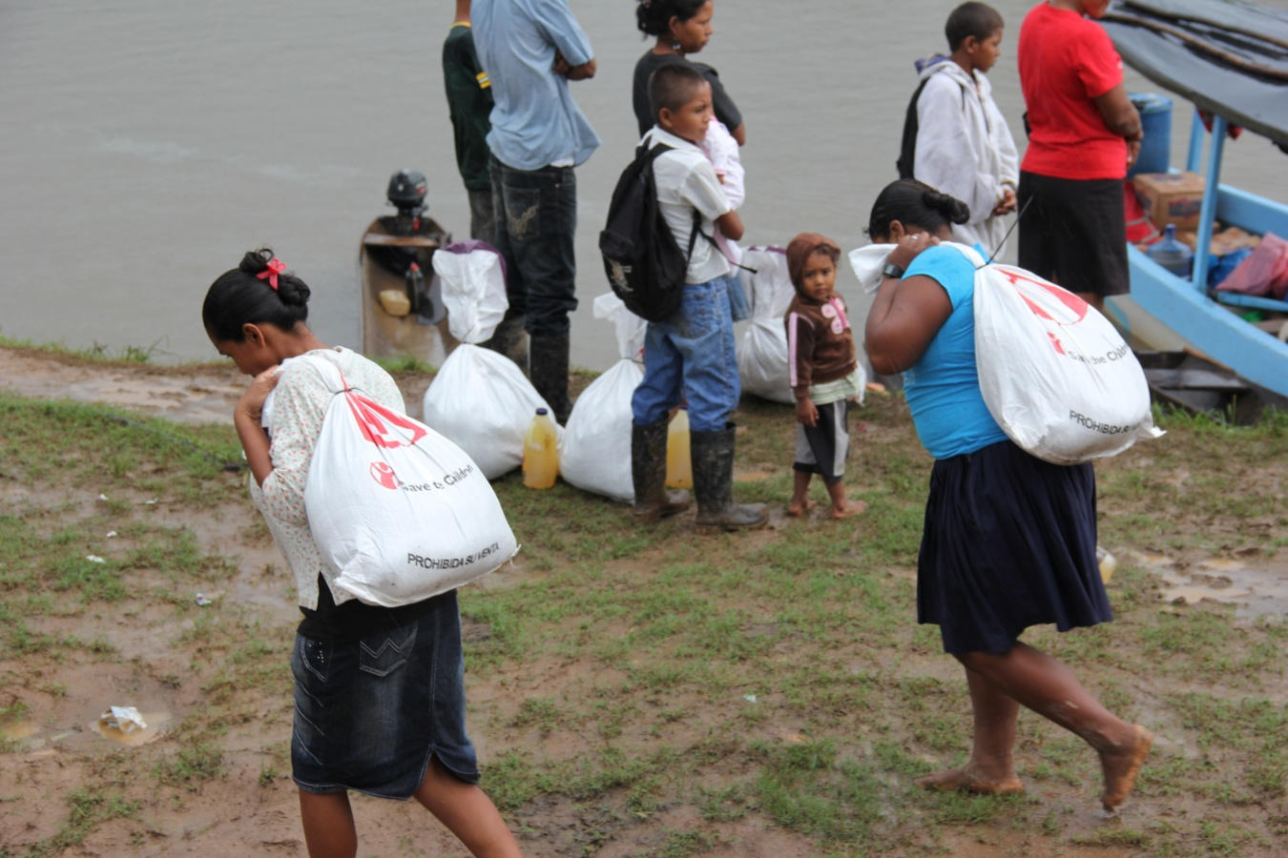  Two women carry bags distributed by Save the Children with food supply. 12.08.13  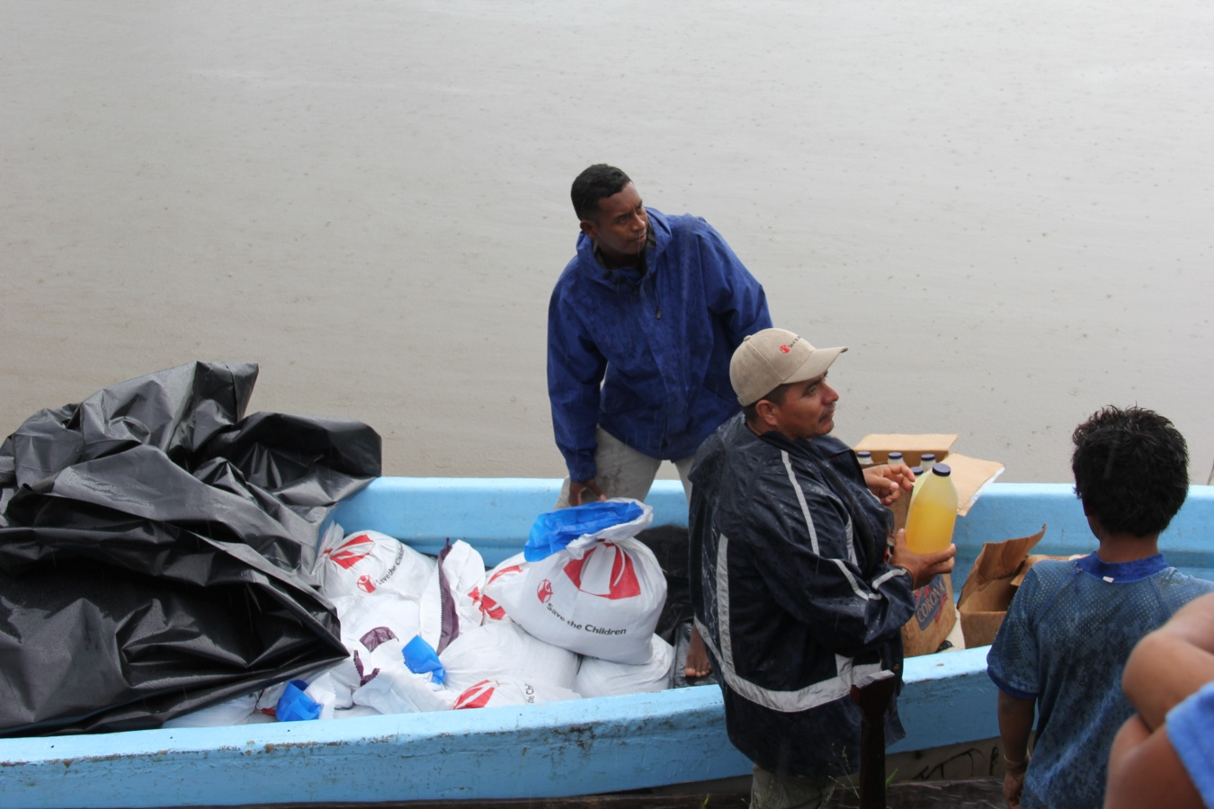  Members of Save Children will distribute food packages and oil from the boat. 12.08.13 Prinzapolka river.  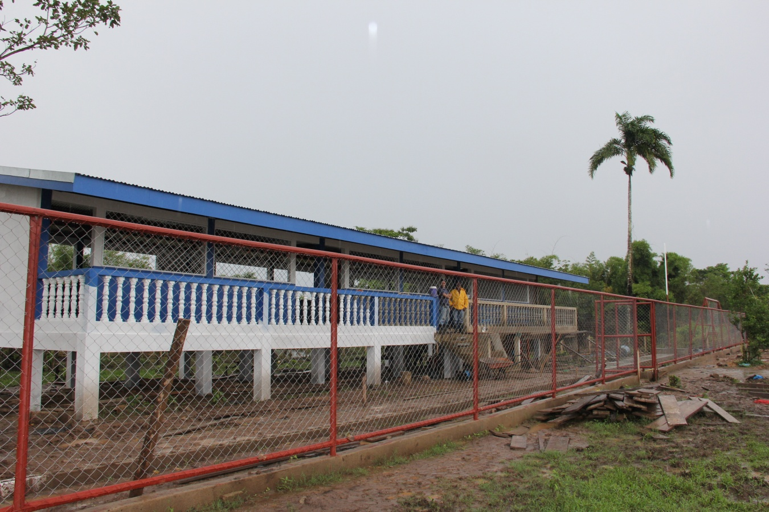  The new school funded by Save the Children in collaboration with Christian Medical Action.  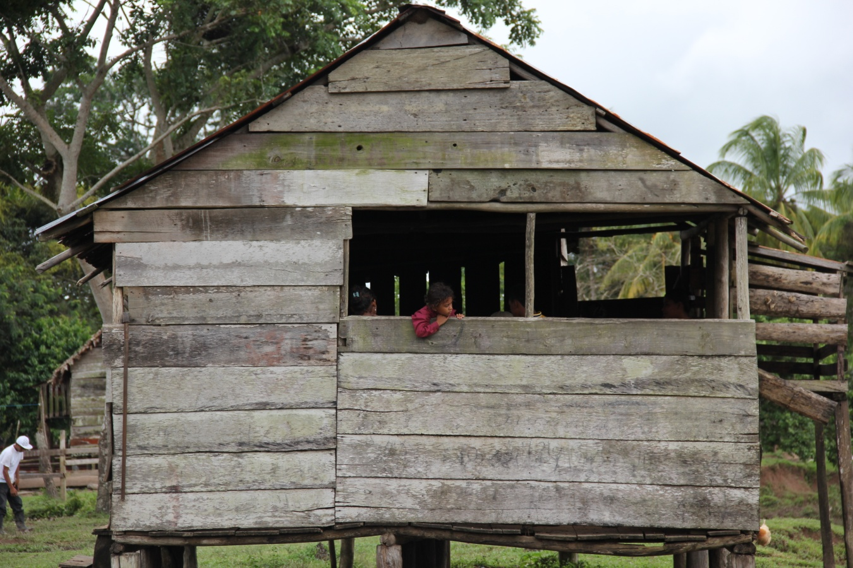  House on bases in Auhya Pura, 12. 08.2013

