CASE STUDY OF A TEAM MEMBER
- A day in the life of …. Yahaira Chavez. Technician at the organization Institute of human development (INPRHU) Managua
- Name: Yahaira Chavez Carcache, 28 years
- Job title: Social Educator, INPRHU Managua, partner of Save the Children.
- Nationality: Nicaraguan
Andrea Núñez-Flores Rey. 12.03.2014. Managua, Nicaragua.
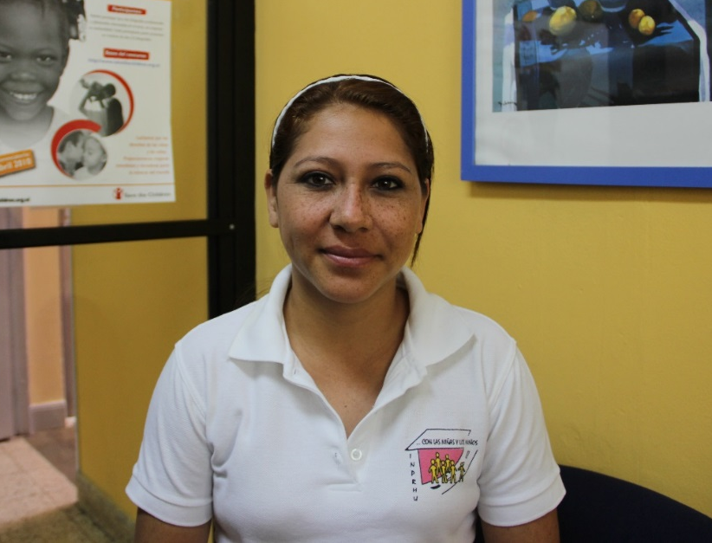
Yahaira is a 28 year old woman, cheerful and hard worker. She comes from a humble background; when she was 11 years old she was accepted as a beneficiary of an INPHRU project because she was a working girl who was at risk of exclusion.
Yahaira in the office of Save the Children
Currently, she works as social educator in the project “Childhood with right to a future,” financed by Save the Children. The objective of this project is to contribute to the reduction of poverty through integral and holistic development of children; particularly, in the creation of educational opportunities for boys and girls; and to a life free of violence.
Yahaira works especially in areas of big local markets where there is a strong presence of working children near schools.
How long have you worked at INPRHU, partner of Save the Children?
I was 11 years old when I was identified as a child at risk and chosen for a project that INPRHU had at that time; they accepted me because I fulfilled all the requirements. We are four siblings; my mother was a cleaning lady and my father was a construction worker.
I was a working little girl, I worked in a market called Israel; I also used to sell things on the street and helped my mother cleaning houses. At the same time I was studying.
INPHRU paid for my elementary and high school studies. Right now, I am almost finishing my studies on sociology, which I had to stop for health reasons. I go to the University on Saturdays because I am always working.
My official professional trajectory at INPRHU started when I was 20 years old, but I am with them since I became a beneficiary. When I was 13, I started as a volunteer monitor and at the age of 14, I started my official volunteer work as a promoter with them. They used to help me with my daily expenses.
When I was 20, they hired me as a social educator. Marvin Moreira, who was my monitor, is now my boss. INPRHU has educated me and has given me all my experience.
Since I started working at INPRHU, I have worked with Save the Children as counterpart.
What do you like about your work as partner of Save the Children?
There are many thinks I like about working with Save the Children. One of the issues I like most is the monitoring. It is not like other counterparts which only finance us and leave all the work for us only care about the results.
Save the Children does more than monitoring and they also support us. Furthermore, they promote many conferences and working commissions on participation and training. They also organize many meetings to get feedback on the knowledge acquired and the work we have done. They tell us what they have learned and we do the same, this way we share knowledge.
Moreover, I like that they are very flexible; other counterparts say: “this is what I want” and that is it, they do not accept anything else. I also like the importance that Save the Children gives to the child participation and active role. They support a lot the recreational activities because, at the end, that is what kids like and learn more.
Yahaira working at the school Republica El Salvador, Managua.
I like all of INPHRU. I owe everything to them. I like to work with children and their families, to know their risk situation and the root of their problems. I have grown at INPRHU.
What don’t you like about your job?
The issue of protection, because it is called “protection” but many times you cannot protect them. We follow up with the complaints we present but many times we cannot do much. When our work ends, another institution has to take part and if they do not follow the complaint, we have not been able to achieve anything.
A DAY AT WORK
What is your job? Explain your main job with the children.
I work as a social educator, but I fulfill with many other duties.
There are some days that I work with kids at the market, others at school; I also have to work with the families, go to the office, write reports, etc.
For example, to do the trainings, first we plan the activities, we create the methodological design and we coordinate with the school.
Trainings are often like this: first, we welcome the participants; we play games with the kids to work on their self-esteem, their aspirations, their goals, and so son. Kids say “I want to be a police because I want to catch the thieves,” they also say they want to be teachers, like me.
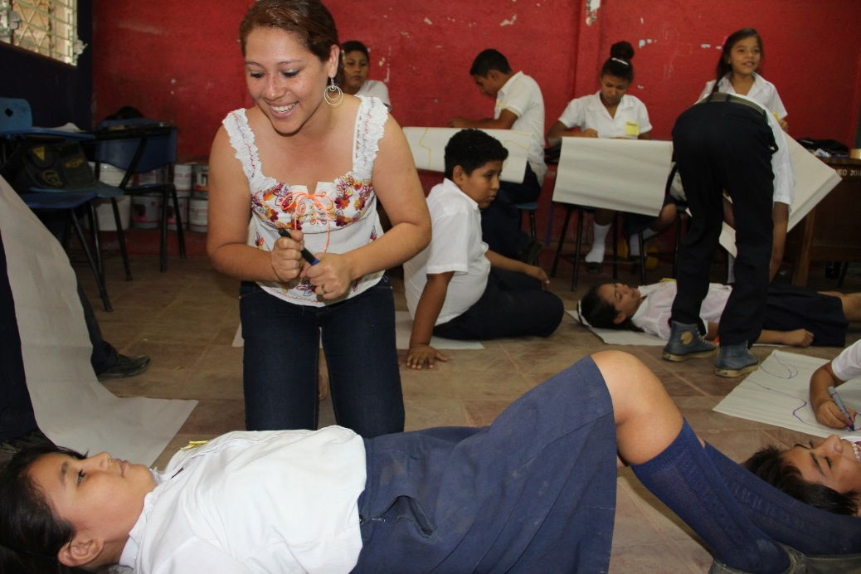
Yahaira and a student during an activity on self-esteem, Managua. 12.03.2014
Some worker children say that they want to be like their parents and continue working at the market; then, we treat them individually. Our goal is that they feel that they want to be better and improve themselves, we ask them why they want to stay in the market when is so dangerous there, and they say that they will not be able to study because they do not have any money. They are children who see no future for themselves.
We also work on their self-esteem; for example, about their personal body image. FUNARTE (another organization counterparts of Save the Children) has trained us on psycho-affectivity.
An example of this activity is that we put a mirror in front of the kids and we tell them to look at themselves, to touch their faces… The mirror is full of nice words. The idea is that they learn to love themselves, they feel important and they know themselves. We tell them that each one of us is unique, we are all different, so there is nothing to feel bad about.
To increase their self-esteem, we also highlight the opinions and ideas of all of them. We talk to them in a positive way. At the end of each activity, we evaluate and they tell us how they have felt, what they liked more… we try that all of them participate in an integral way.
On the other hand, we do follow cases in which children are not being protected in their homes or have problems. To achieve this, we organize team meetings with “referents”, adults we have trained. The purpose of the training is that they can do social control, identify cases, and also they can follow the complaints process. Normally, they are teachers or people that work at the marked. They inform us when a child may be suffering abuse, or he/ she does not go to school or to meetings, for instance.
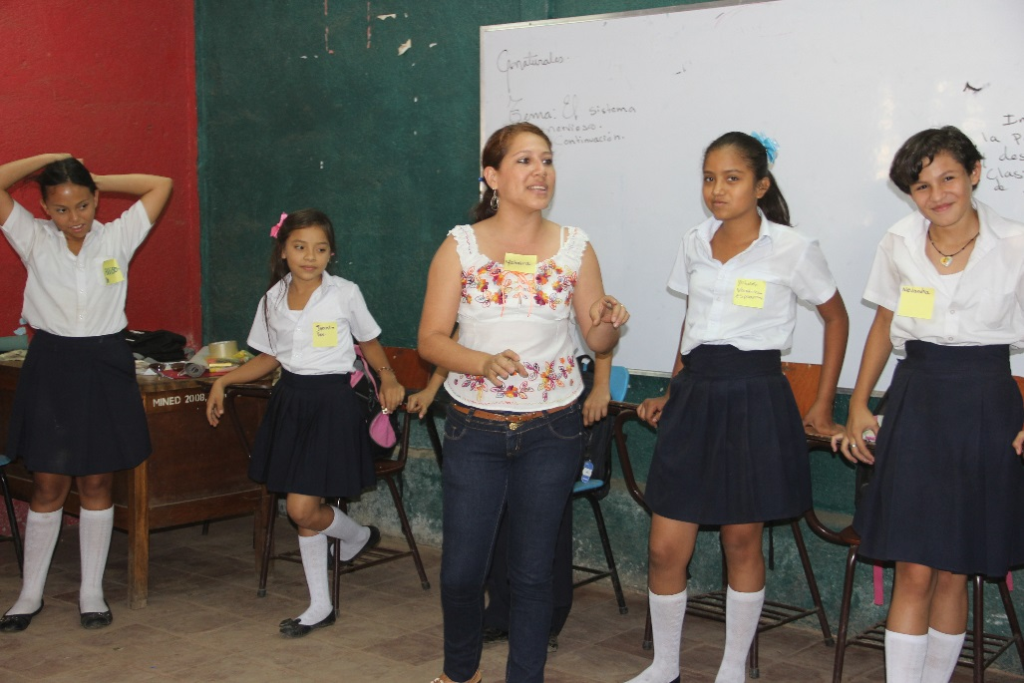
After that, we plan a visit and the purpose of it. Then, we go to the houses to talk with the families accompanied with the “referent”. Once we are in the house, we observe the house and the parents’ attitude, which tell us a lot. We listen without judging them, to find out their situation and their problems. There are some families that do not accept us and they say “why do you get involved?” Do you feed my child?” Then, you have to rethink the strategy.
Yahaira during an activity at the school
In cases of sexual child abuse, we have a safe house for girls that have been abused. In this cases, we talk first with the “referent”, the school director and we proceed with the case detection process. After that, we have to work with the Commissary for Women and Children (Comisaría de la Mujer y la Niñez).
On the other hand, at the market, we support and help the kids with their homework and school subjects.
Is there anything that have impact you at work?
Always, the protection cases are those that most affect me. Some years ago, we were informed that an 8 year old boy at the market was all bruised; his mother had mistreated him a lot.
We presented the complaint at the police station, we were there a lot of hours waiting for a solution, and we had to leave without any answers. We felt powerless because we could not do anything more. The next day, the kid was with his mother again. That is the part of protection that I do not like, when is not in our hands to be able to help a child.
What makes you especially proud of your job?
When lots of kids talk about rights. Sometimes, the parents tell us that we have taught the children about their rights but that they do not do their duties. When I see worker children of humble origin at the market talking about children’s rights, I feel very proud.
Also, when the children start to like themselves more, they have more self-esteem, because when they start with us they do not feel they are special and they do not value themselves. But, slowly they learn to love themselves and they have more self-esteem.
Another thing that makes me proud is when I see kids that were violent, who had aggressive behavior, and they change, they are not using violence.
It also makes me feel proud when I see them taking initiative on their own to participate, the come up with ideas for activities or games, they ask for meetings.

YOUR THOUGHTS AND OPINIONS ABOUT YOUR JOB
When you were a child, did you image that you were going to work in this kind of work?
When I was little I could have never imagined this. The man, who was my educator when I was a child, is now my boss. When I was little, I did not have any dreams, I thought that I would always be under the scope of my parents.
Where do you see yourself in the future?
Always working. In the future, I see myself working in the social area because that is what I like. Right now, I have the opportunity to work in something that I had never done before, is a scholarships project for young people, and I had never done this before. At the beginning, I was scared, but I am sure I can overcome any changes because I have a lot of experience, thanks to INPRHU.
Something that inspires you, that makes you especially happy?
To see that I cause good changes in children; that I make a mark on their lives.
For example, there is a little girl who works at the Mayoreo market. She picks up and collects vegetables and fruit that people throw on the floor. This little girl has suffered a lot because she is discriminated. She was always dirty. One day, I told her, “you are so pretty, but you would look prettier if you would wash your face and you pick your hair out of your face”. Since then, she always come to the market with her clean face.
3-4 OTHER SENTENCES OF THE WORKER
- I like everything of my work at INPHRU. I love to work with children and their families.
- Almost all of the parents and children call me “the teacher”
- I like to organize recreational activities, because these kinds of activities are the ones that the children like. They don’t learn the same if you only tell them things and they listen.
- Sometimes, I think that is an advantage that the children see me younger than I am, because they feel more identified with me; even though, sometimes this creates friction with the parents that do not want us to get involved with their children’s life, because they tell me that how can I know better if I am still too young.
- I feel good when the children increase their self-esteem. There was a little girl that did not like herself because she said she was fat, and now she tells me “I am pretty, teacher, don’t you think so?
- Many kids tell me they want to be a teacher like me, because I am a good person.
- I always include the gender perspective in every activity.

PROJECT: “CHILDREN WITH RIGHT TO A FUTURE”
INPRHU is the Institute for Human Promotion in Nicaragua, a non-governmental organization that promotes children rights, especially the right to an education and the non-violence of working girls and boys, with special approach on the protection and integral promotion of their rights.
This project, financed by the area of Education at Save the Children, started in 2010 and goes on until 2014, it is executed with three counterparts, CAPRI, INPRHU Ocotal, and INPRHU Managua.
The specific objectives are to contribute and increase the access and permanence of boys and girls in their school, in coordination with the Ministry of Education and other social sectors; promoting gender equity; and the access to education for: younger kids than six years old; children with some kind of disability; worker kids; or victims of exclusion due to limited educational centers, or because of their financial or social condition.
Objective 2: Contribute to increase the quality of the regular and non-regular education programs, pre and basic education, to increase the learning capabilities of girls and boys, contributing to their psycho-affective development.
Objective 3: Strengthen the capabilities and abilities of the organizations in the community, for children, adolescents, young people and mothers- fathers networks, for the promotion of children rights, contributing to the development of relationships of respect and protection by adults, and the active participation of girls, boys, and adolescents in exercising their rights.
Objective 4: Strengthen the articulation of the educational community and their ability to influence the policies, programs and educational practices at the district, municipal, department and national levels.

