ROLE PROFILE: Specialist, Humanitarain Team Operations |  | 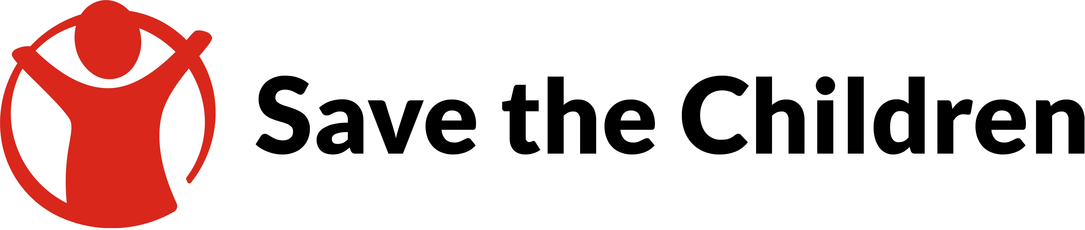
Position Title: | Specialist, Humanitarian Team Operations
Position ID: | 274749542

Team | Humanitarian Strategy & Performance | Grade | P3
Reports To (Title) | Head of Humanitarian Performance & Planning | Contract Length | 6 months initially with possibility to extend (subject to funding)
Location | Any existing SCI office location (multiple timezones and locations required across team) | Time-zone | Any (multiple timezones and locations required across team)
Languages | English (additional language of French, Spanish or Arabic preferred) | Headcount | 1

Team and Job Purpose
Team purpose
To oversee the global humanitarian response portfolio, ensuring the integration of humanitarian needs into strategic country plans to enhance program effectiveness. By tracking and driving progress against strategy and cross-sector commitments, we aim to sustain and optimize humanitarian funding. This enables us to respond effectively to global needs while aligning with Save the Children's strategic priorities.

Role purpose
To manage and oversee the effective implementation of staff-related policies and processes within the humanitarian team, ensuring alignment with Save the Children's values and practices of equity, diversity, and inclusion, while supporting line managers in the induction, onboarding, and continuous development of humanitarian staff to foster a culture of inclusivity and mutual respect.

Principal Accountabilities
- Manage the implementation of staff-related policies and processes within the humanitarian team, ensuring compliance with Save the Children's values and commitment to equity, diversity, and inclusion in alignment with organisational standards.
- Support line managers in the induction and training of new humanitarian staff, facilitating their smooth integration, and promoting a culture of inclusivity, mutual respect, and continuous learning opportunities.
- Maintain and update key resources ensuring that relevant policies and the humanitarian team staff handbook are accessible and current for all team members.
- Track and report on training and professional development activities, ensuring all employees have equal access to learning resources and opportunities for growth, in line with the organisation’s commitment to continuous improvement.
- Oversee knowledge management systems, including OneNet, SharePoint, and distribution lists, guaranteeing that information is accessible, current, and supports the efficient functioning of the humanitarian team.
- Project manage governance and management group meetings, such as SMT, ESMT, and HLG, by managing agendas and tracking deliverables, working closely with the humanitarian team coordinator to ensure effective scheduling and follow-up.

Budget
None

People Management Responsibility (direct/indirect reports)
Number of people managed in total: None
Manager of a team: No
Team Manager (manager of multiple teams): No

Size of Remit
Global

Travel Requirements
International travel required: Yes

Percentage of required for travel: Up to 10%

Key Relationships
Internal (excluding direct team and manager)
- Colleagues in operational support functions such P&O and Finance

Competencies
Cluster: Leading
Competency: Developing self and others
Level: Accomplished
Behavioural Indicator: Identifies clear development needs and development plans through regular constructive reviews of their own performance (and their team’s where appropriate).

Cluster: Leading
Competency: Leading and inspiring others
Level: Accomplished
Behavioural Indicator: Takes a flexible and positive leadership style adapting to a given situation or to the needs of the team.

Cluster: Thinking
Competency: Problem solving and decision making
Level: Accomplished
Behavioural Indicator: Analyses and exercises judgment in challenging situations where specific guidance or the full facts are not available.

Cluster: Thinking
Competency: Innovating and adapting
Level: Accomplished
Behavioural Indicator: Builds others’ confidence in their own ability to develop new ideas and embrace change.

Cluster: Engaging
Competency: Communicating with impact
Level: Accomplished
Behavioural Indicator: Promotes dialogue with key stakeholders through active listening and effective questioning.

Cluster: Engaging
Competency: Working effectively with others
Level: Accomplished
Behavioural Indicator: Enables people from a wide range of backgrounds and perspectives to contribute to positive outcomes.

Experience and Skills
Essential

- Communication & Interpersonal Skills: Approachable, a good listener, and able to communicate effectively with people from diverse backgrounds. Ability to convey complex information clearly and empathetically.

- Training Development & Delivery: Ability to design, deliver, and evaluate training programs that reflect equitable, diverse, and inclusive principles. Demonstrated ability to notice gaps and improve training materials. Experience in tracking and reporting on training and professional development activities, promoting continuous learning.

- Project & Team Coordination: Proficient experience in coordinating operational process improvement initiatives, including governance and management group meetings, tracking deliverables, and ensuring effective scheduling and follow-up. Adept and agile at sharing and delegating tasks.

- Knowledge Management: Experience in managing knowledge resources and platforms such as OneNet, SharePoint, and distribution lists to ensure information accessibility and currency for all team members.

- Advisory Skills: Skills in advising and supporting line managers in the induction, onboarding, and training of new humanitarian staff, fostering a smooth integration process and promoting a culture of inclusivity and respect.

- Data Analysis and Reporting: Ability to collect, analyse data, and generate reports related to equity, diversity, and inclusion to track progress and inform decisions.

- Problem-Solving Skills: Creative and innovative thinking with the ability to develop new solutions to challenges faced in the implementation of staff-related policies and processes.

- Equity, Diversity, and Inclusion: Committed to fostering a culture of inclusivity, mutual respect, and equity within a team environment and demonstrates the ability to do so.

Desirable
- Additional language of French, Spanish or Arabic preferred

Education and Qualifications
Essential

- Bachelor’s degree in a relevant field or equivalent work experience

Desirable
- Recognised Project Management qualification

Safeguarding
We need to keep children and adults safe so our selection process includes rigorous background checks and reflects our commitment to the protection of children and adults from abuse.

Level 1: A basic criminal record background (DBS) check is required/equivalent police record check.

Diversity, Equity and Inclusion and Equal Opportunities
Diversity, Equity and Inclusion is core to our vision, values and global strategy. Save the Children is committed to creating a truly diverse, equitable and inclusive organisation, and one which will support us in our vision to ensure every child attains the right to survival, protection, development, and participation.

We are committed to equal employment opportunities, regardless of gender, sexual orientation, race, colour, ethnic origin, nationality, disability, marital or civil partnership status, gender reassignment, pregnancy and maternity, caring or parental responsibilities, age, or beliefs and religion. We are committed to diversifying our staff to better represent the communities we serve and actively welcome underrepresented groups to apply.

Reasonable adjustments will be made should any candidate invited to interview require this.

Version Control and Approval
Version | Date | Author | Reviewer | Approver
1 | 15/08/2024

